- DDL - DDL (Data Definition Language) is a subset of SQL used to define, create, modify, and delete database objects such as tables, views, indexes, schemas, and constraints.
- DDL commands change the structure of the database and their effects are permanent (they are automatically committed).
DDL COMMANDS:
CREATE : Creates database objects
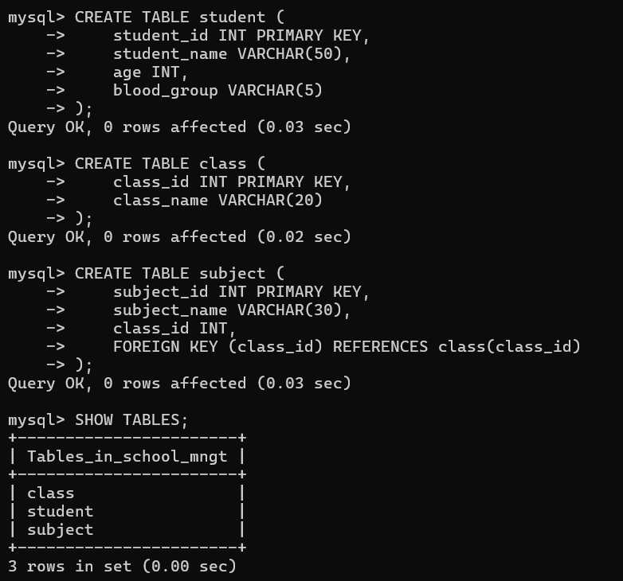

ALTER : Modifies existing objects
ALTER TABLE – ADD: The ADD clause is used to add a new column or constraint to an existing table.
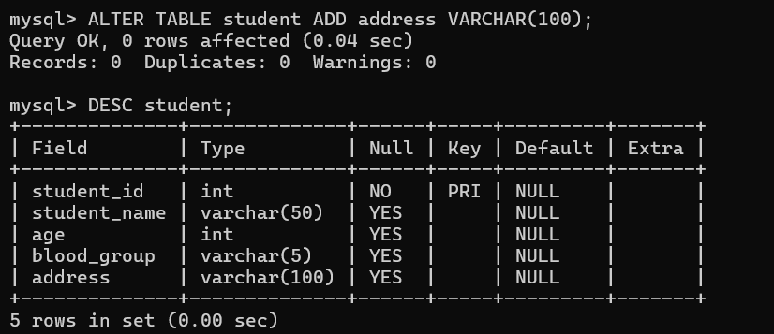
ALTER TABLE – MODIFY: The MODIFY clause is used to change the datatype, size, or properties of an existing column.
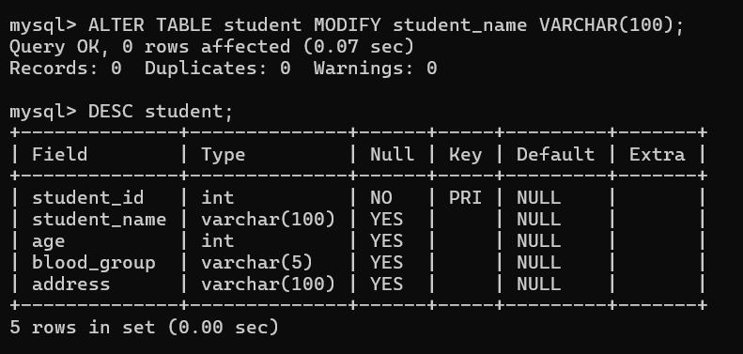

ALTER TABLE – DROP: The DROP clause is used to remove an existing column or constraint from a table.

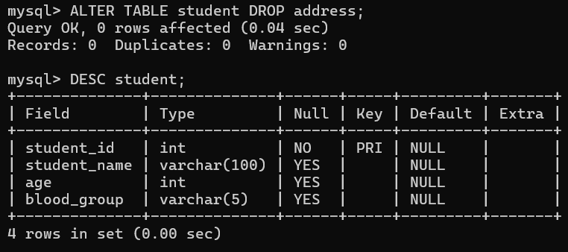
DML:
DML (Data Manipulation Language) is a subset of SQL used to insert, retrieve, update, and delete data stored in database tables.
DML commands work on the data inside the table, not on the table structure.
DML COMMANDS:
INSERT: Adds new records
SELECT: Retrieves record
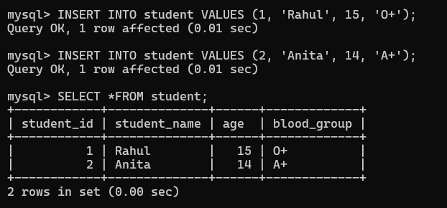
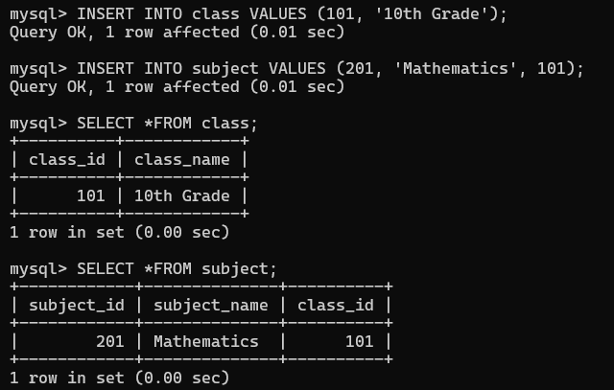
UPDATE: Modifies existing records
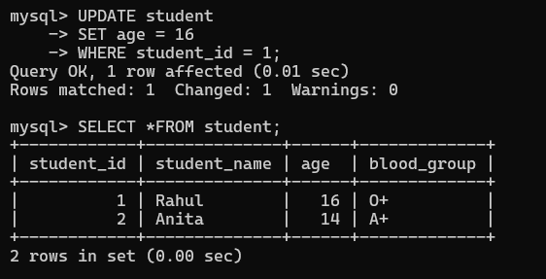
DELETE: Removes records
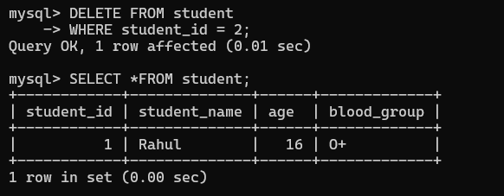

TCL:
TCL (Transaction Control Language) is a subset of SQL used to manage database transactions and control changes made by DML commands.
It ensures data consistency and integrity in a database.
TCL COMMANDS:
COMMIT: Saves changes permanently
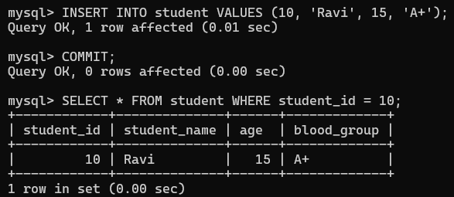
ROLLBACK: Undoes changes
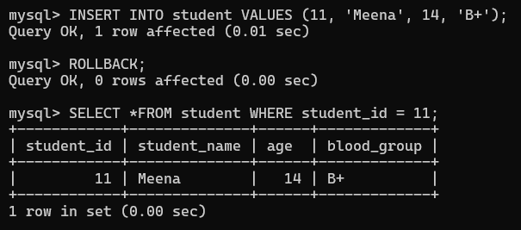

SAVEPOINT: Sets a point to rollback
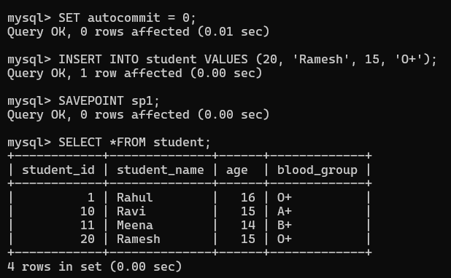
DCL:
DCL (Data Control Language) is a subset of SQL used to control access and permissions on database objects such as tables, views, and procedures.
It helps ensure database security by deciding who can perform what operations.
DCL COMMAMNDS:
GRANT: Gives permissions to users
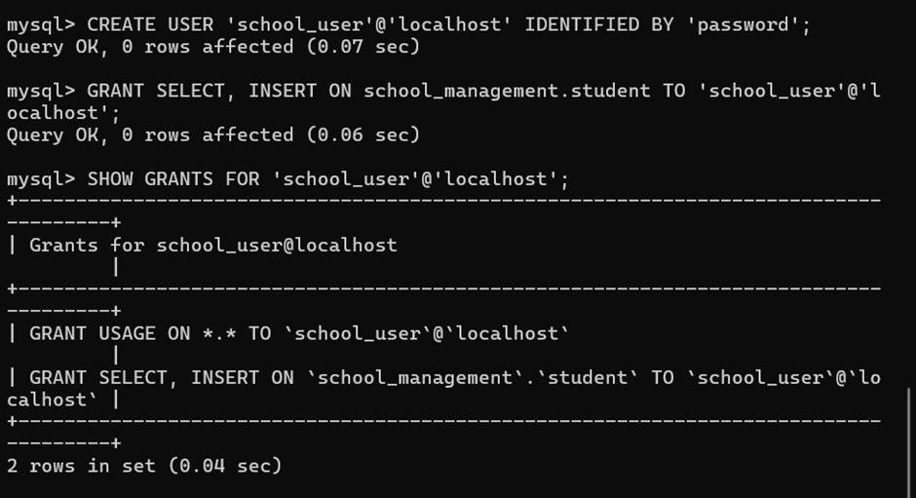
REVOKE: Removes permissions from users
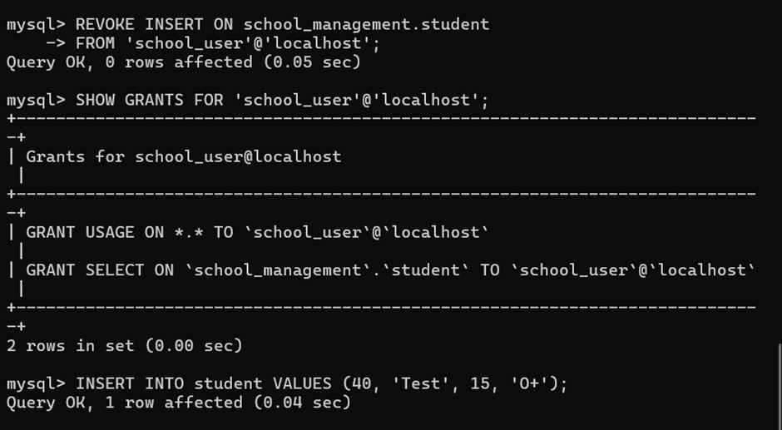
JOINS: used to retrieve data from multiple tables by matching values in common columns.
INNER JOIN: returns matching records from both tables
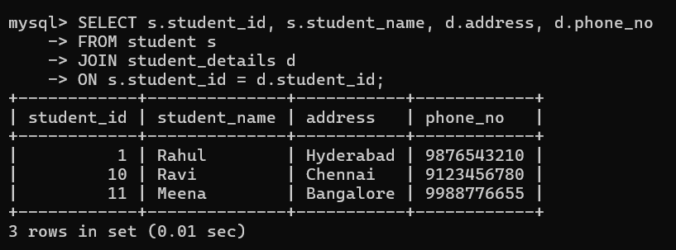

LEFT JOIN: returns all records from left table and matching ones from right
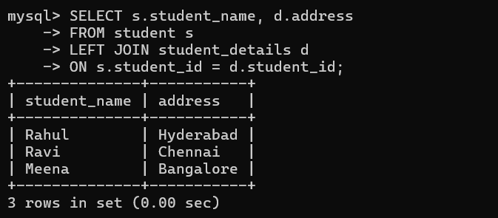
RIGHT JOIN: returns all records from right table and matching ones from left
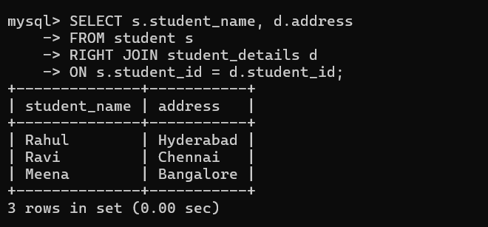

AGGREGATE FUNCTIONS: Work on multiple rows and return one value
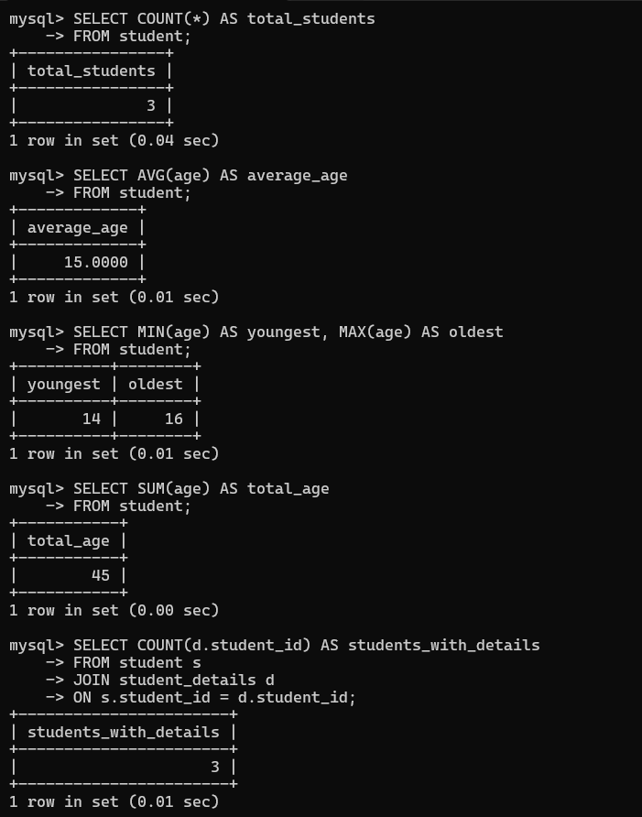

CLAUSES: Clauses are parts of an SQL query used to control the selection, filtering, grouping, and ordering of data.
- WHERE – filters rows based on a condition
- GROUP BY – groups rows with same values
- HAVING – filters grouped data
- ORDER BY – sorts the result
- DISTINCT – removes duplicate values
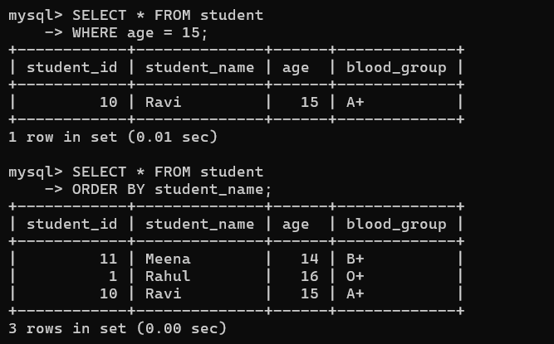
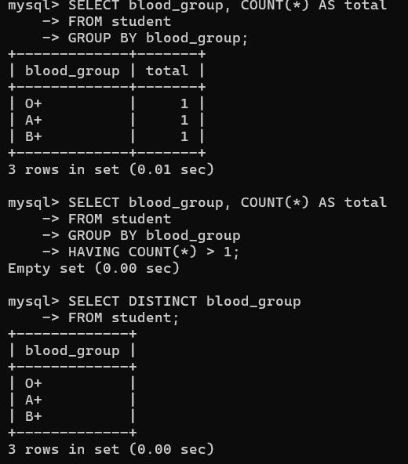

VIEW:
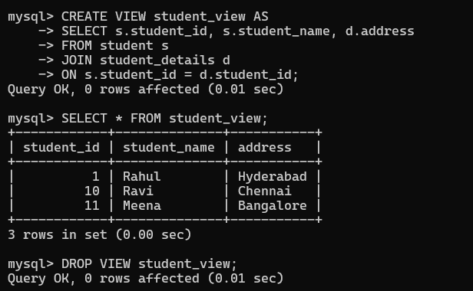
TRIGGER:
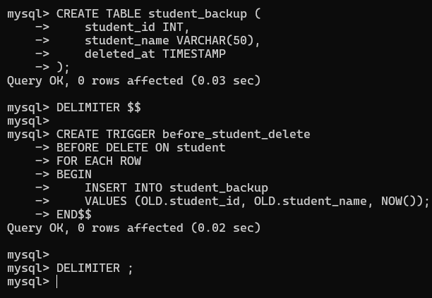
EXCEPTION HANDLING:
